Week 9 – Submit Task
Question 1
(VCAA Algorithmics Examination 2021)
You must also explain your answer below.
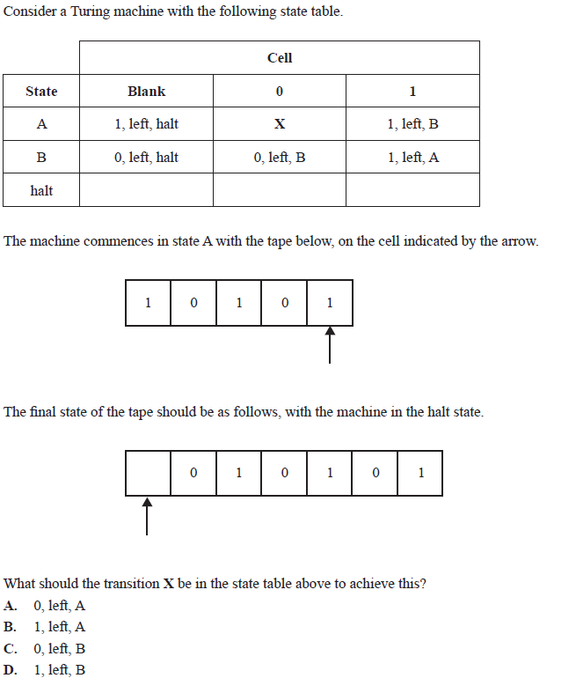
A: on the fourth step the TM looks like 10101 (green is where the head is) in state A.
By picking A, the TM will read the zero, rewrite a zero on that cell and then move left while staying in state A. Once the head is on the leftmost 1, the state will then transition to state B and move left onto a blank cell. In state B that blank cell will be rewritten to be a 0 as shown, and then the head will move left onto a blank cell.

Each of the following questions is worth 2-3 marks. Provide a short written response.
Question 2
Explain the concept of a Turing machine and its components. How does it simulate the behavior of a computer algorithm?
A Turing machine contains a head, and some tape with two symbols on it, and a blank symbol – usually 0,1, and blank. We can give the TM a set of instructions depending on what state it is in, and it changes between our given states by using the head to read the symbols on the tape, and executing the assigned instruction that the read symbol causes in a certain state until the machine halts.
Question 3
Define undecidability in the context of computer science. Provide an example of an undecidable problem and explain why it is impossible to solve algorithmically.
Undecidability is when an uncomputable problem requires a yes or no answer. If guard 1 says guard 2 is lying, but guard 2 says guard one is telling the truth, which guard is lying? An algorithm for this problem will not work as this is a paradoxical question. Any algorithm we come up with will not halt, and it will also not loop forever as both guards could very reasonably be lying.
Question 4
Define the halting problem and explain why it is considered an undecidable problem. What are the consequences of its undecidability for the limits of computation?
Function A takes two inputs: Problem X and Input Y. Problem X can either halt or loop forever, and Function A has two outputs: No if problem X halts, and Yes if problem X loops forever. This is a yes or no question: will problem X halt or not halt. If it halts, then Function A outputs No, it wont halt, and Yes if it loops forever. This is a paradox. We cannot prove that there is a solution to this problem.
Question 5
Discuss the relationship between the halting problem and Gödel's incompleteness theorems. How do they both relate to the concept of undecidability?
Gödel's incompleteness theorems state that unprovable true statements exist, whereas the halting problem is a problem that leads into a paradox. The halting problem can be described as a problem that supports Gödel's theorems, because the output being neither true or false proves that the problem is undecidable.

